# Progress Report

## Synopsis of the Last Meeting

During the last meeting, I had initial doubts about the dimensionality reduction performed by the Sammon’s Projection.

## Experiment of Sammon’s Projection

I have carried our Sammons projection on the maps generated by the GSOM for nine players. Following are the parameters and the statistics associated with the GSOM training.

|  |  |  |  |
| --- | --- | --- | --- |
| Spread Factor | Learning Rate | Radius | Iterations |
| 0.9 | 0.25 | 7 | 100 |

Figure 1 - GSOM Parameters

|  |  |
| --- | --- |
| Number of Players | 9 |
| Number of data vectors (per player) | 400 |
| Testing Modes | 2 (Walkthrough Mode(**W**)/Game Mode(**G**)) |

Figure 2 - Data Statistics

* The walkthrough mode data was collected by observing player movement through the Pac-Man maze. There were no AI elements involved in this mode and the player was allowed to move freely.
* The game mode presents the full Pac-Man game with the AI opponents. The data recording mechanism is the same as for the walkthrough phase.
* There are 24 possible moves across 9 junctions in the maze. Correspondingly, there are 24 hit nodes in the GSOM (expected result) unless a player does not take a particular move for the entirety of the experiment.
* All maps were generated using a constant set of weights across all players when training the GSOM.
* Similarly, same set of randomly generated 2D and 3D data points were used for the Sammon’s projection.
* The optimization technique specified by Kohonen is used (due to implementation efficiency) opposed to the gradient decent proposed by Sammon.

## Results

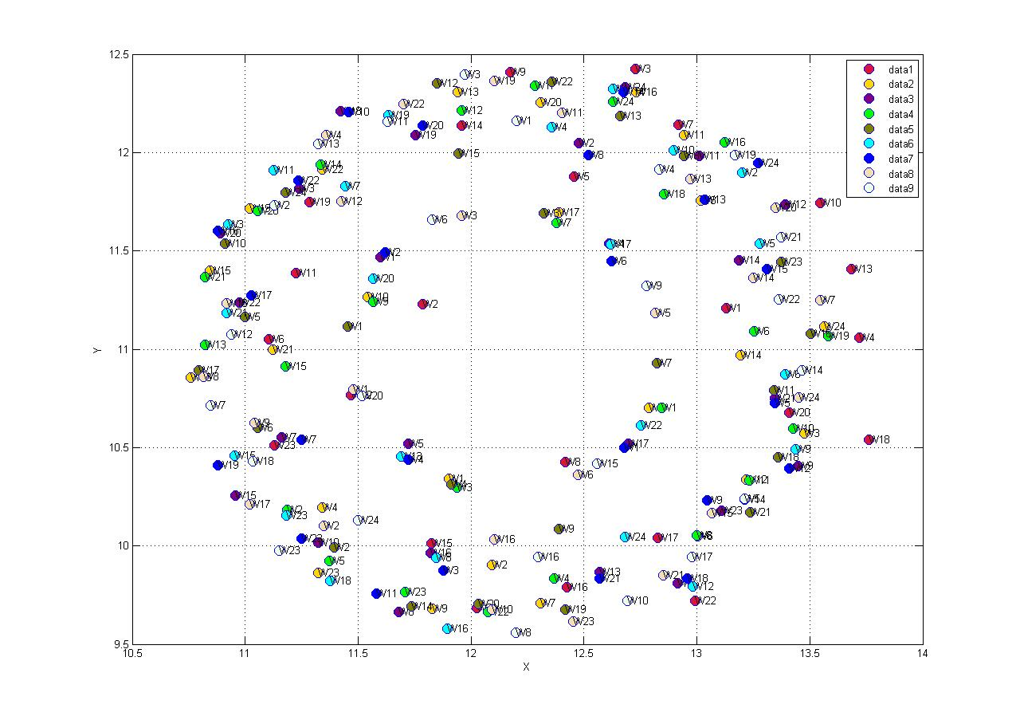

Figure 3 - Sammon's Projection of Nine Players (W Mode)

* Initially the GSOMs generated for the W mode of all the nine players were mapped to a 2D point. The end result is depicted in Figure 3. Each color represents an individual player and each colored dot represents a winner node in the GSOM. There are 24 winners in total per player except on a single player. From my observation I see that the data is highly correlated among the players. When checking what each point in the Sammon’s projection represents it is clear that similar input vectors have mapped into close proximity. The G mode data of all the nine player used for this experiment was plotted using the same methodology as explained above and the results are depicted in Figure 4. The same observation could be made about the game mode but it seems the data points are closely packed when comparing with Figure 3. Apart from that I do not observe any outlier or an alarming pattern on player behavior. Possible reason for this might be
  + Structure of the game. Since the data was generated from a simple maze type game, most player behaviors are constrained and therefore the GSOM winners and the mapping too are constrained. Possible remedy is to check with a dataset of higher diversity.
  + Another reason for the circular pattern may be the dependency of input vectors to each other.

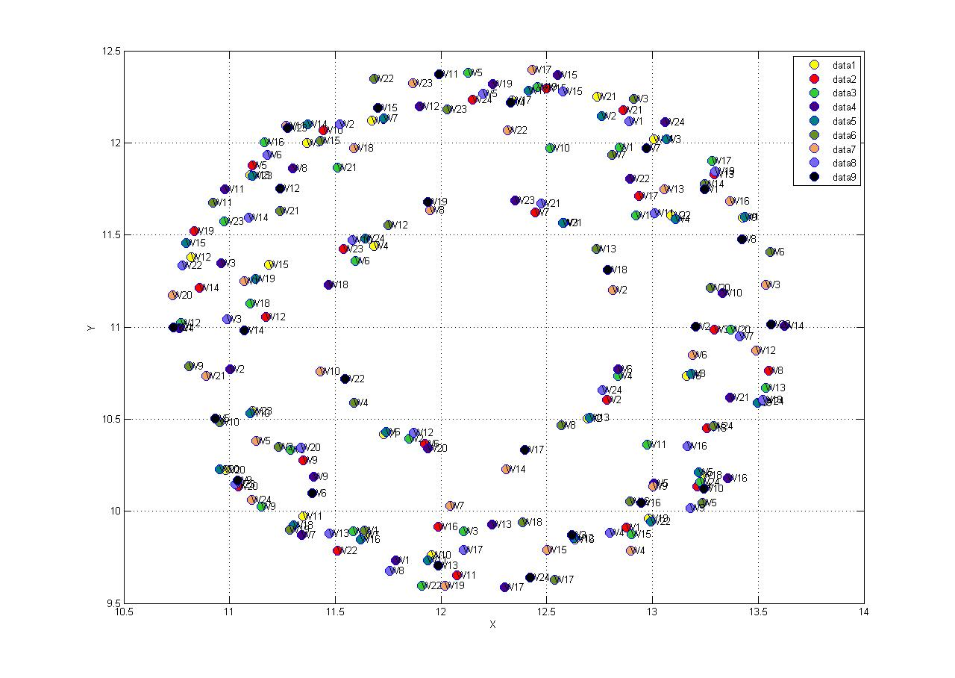

Figure 4 - Sammon's Projection of Nine Players (G Mode)

* After the primary observations each player W mode and G mode was plotted together to observe the correlation between the game modes. The following figures represent these plots for the nine players used in this experiment. Eventhough, some player have a higher correlation between the two modes than other there are no solid patterns could be observed from my point of view. The individual mapping too preserves the circular pattern observed in Figure 3 and Figure 4.

## What I need to be discussed during this meeting

* Discussion on the results obtained above.
* I think the above result is insufficient to move forward I have some ideas with respect to moving forward but I need to get your views on the results obtained first before moving towards them.
* Should I check the same plots in 3D space? Or reduce it to 1D space?